Measuring – How Much?

2

Measuring Ingredients

*How Much* Do You Need?

# Measuring Cups

for **BIG** amounts

2 cups

500 ml

1/4 cups

50 ml

1/3 cups

75 ml

1/2 cup

125 ml

1 cup

250 ml

_____________________________________________

_____________________________________________

Good for **DRY** foods:

ex:

flour

sugar

rice

Good for **WET** foods:

ex:

milk

water

oil

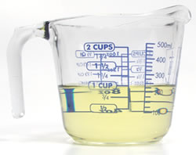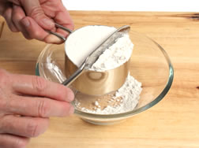

!

_____________________________________________

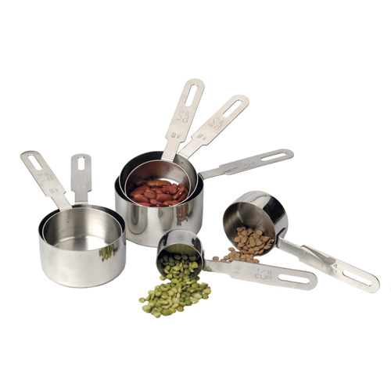

for **SMALL** amounts

1 **Table**spoon

15 ml

# Measuring Spoons

1/4 teaspoon

1 ml

1/2 teaspoon

2.5 ml

1 teaspoon

5 ml

## tsp

## Tbsp

Good for **WET** and **DRY** foods:

ex:

salt

cinnamon

baking soda

